Branching Workflow – Add & Verify a contact page
Olajide Kuti
Assignment 10:
Task 1 – Confirm Repository State and Default Branch
Screenshot 1
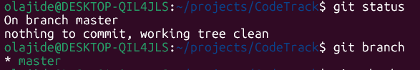
Task 2 – Create and Switch to a Feature Branch
Screenshot 2
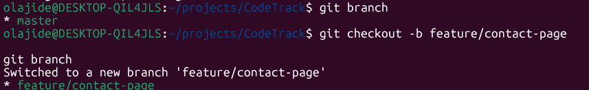
Task 3 – Add contact.html on the Feature Branch
Screenshot 3
Screenshot 4
Screenshot 5
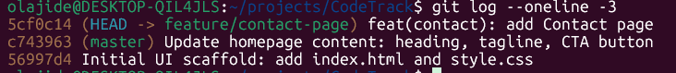
Task 4 – Add the Contact Link to Index.html
Screenshot 6
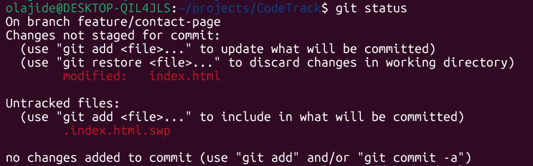
Screenshot 6 - a
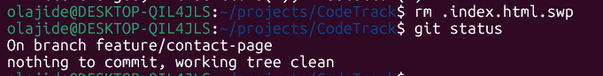
Screenshot 7
Screenshot 8
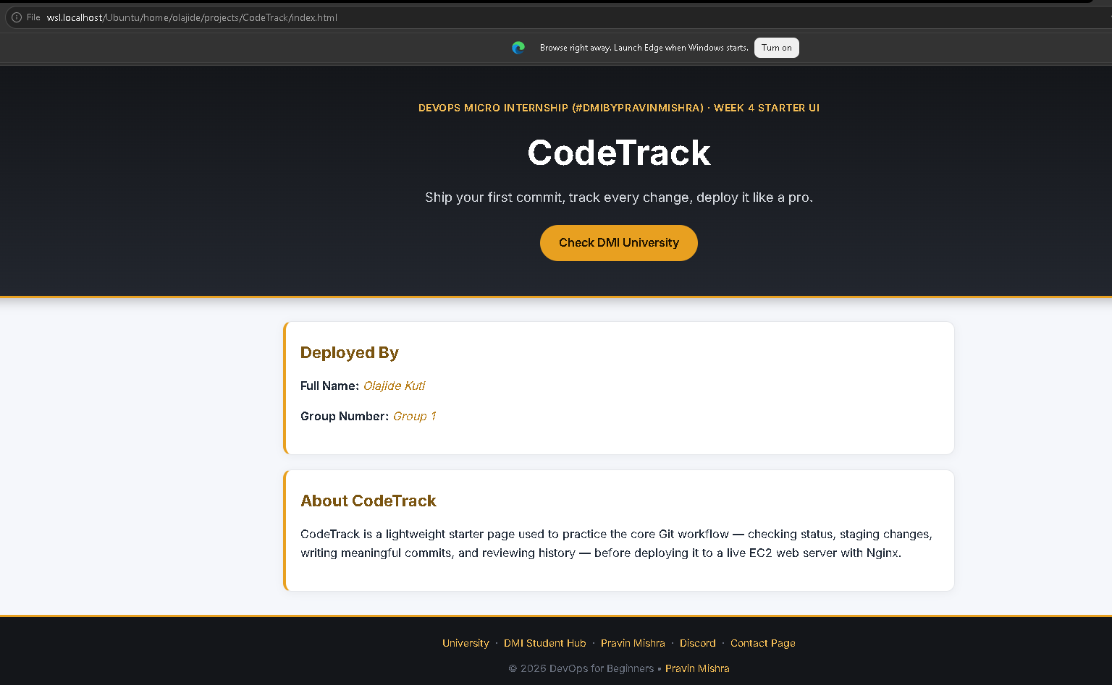

Task 5 – Verify Isolation (Prove the Default Branch is Unchanged)
Screenshot 9
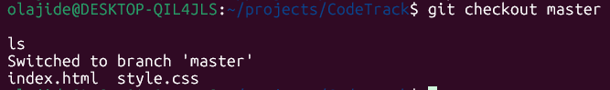
Screenshot10
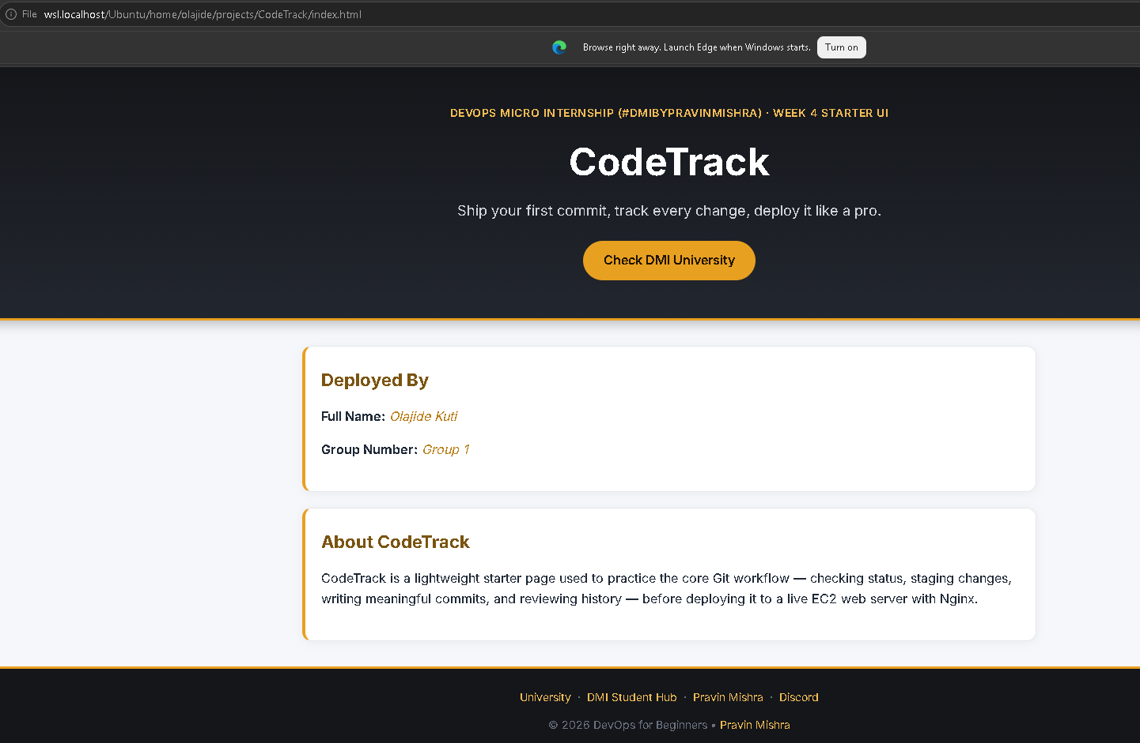
Task 6 – Merge the Feature Branch into the Default Branch
Screenshot 11
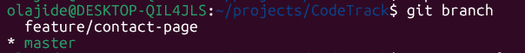
Screenshot 12
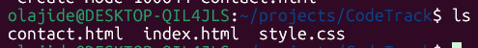
Screenshot 13
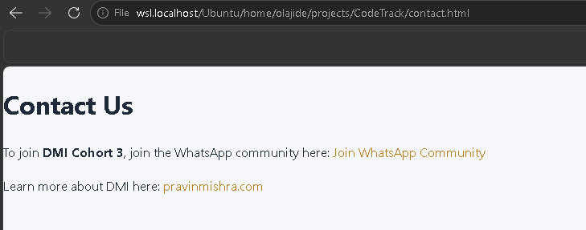

Task 7 – Inspect History (Graph View)
Screenshot14
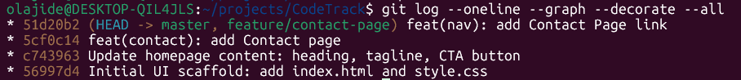
Screenshot 15
